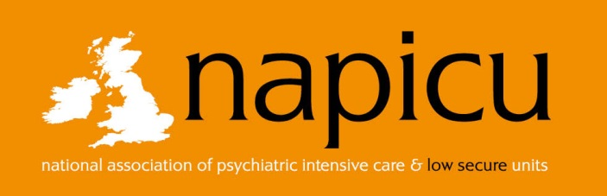
Order Form

Personal Details
Family Name: |  |  |  |  |  |  |  | Title (Prof/Dr/Mr/Ms/Other)
First Name:
Trust/Organisation:
Address:
City: |  |  |  |  | County: |  | Postcode: |  | Country:
Phone: |  |  |  |  | Fax: |  | Email:
Order
 | Cost | No | Sub-Total
National Minimum Standards Document Members Rate (inc. P&P) | £22.50
National Minimum Standards Document Non-Members Rate (inc. P&P) | £27.50
NMS for PICUs for Young People Members Rate (inc. P&P) | £25.50
NMS for PICUs for Young People Non Members Rate (inc. P&P) | £30.50
Postage to an address outside of the UK | Quoted on receipt of order
 | Total:

Delivery address if different from above:
Family Name: |  |  |  |  |  |  |  | Title (Prof/Dr/Mr/Ms/Other)
First Name:
Trust/Organisation:
Address:
City: |  |  |  |  | County: |  | Postcode: |  | Country:
Phone: |  |  |  |  | Fax: |  | Email:

Payment Information
Address for invoice, if different from above:
Name: |  |  |  |  |  | Purchase Order No:
Address:
Postcode: |  |  |  | Email: |  |  | Phone:

To pay by card please complete section below (Amex not accepted)
Card Number
Expiry Date (MM/YYYY): |  |  |  |  |  |  |  |  |  | Security Code (last 3 digits):
Cardholder’s Signature: |  |  |  |  |  |  |  |  |  |  |  |  | Date:

Once received, your order will be processed and an invoice sent for payment by either BACS or cheque. If credit card details have been provided your order will be processed and payment taken.
Please note: your order will not be dispatched until payment has been received.

Please return completed form to the administration office by email, fax or post (details below)

