Floor Plan

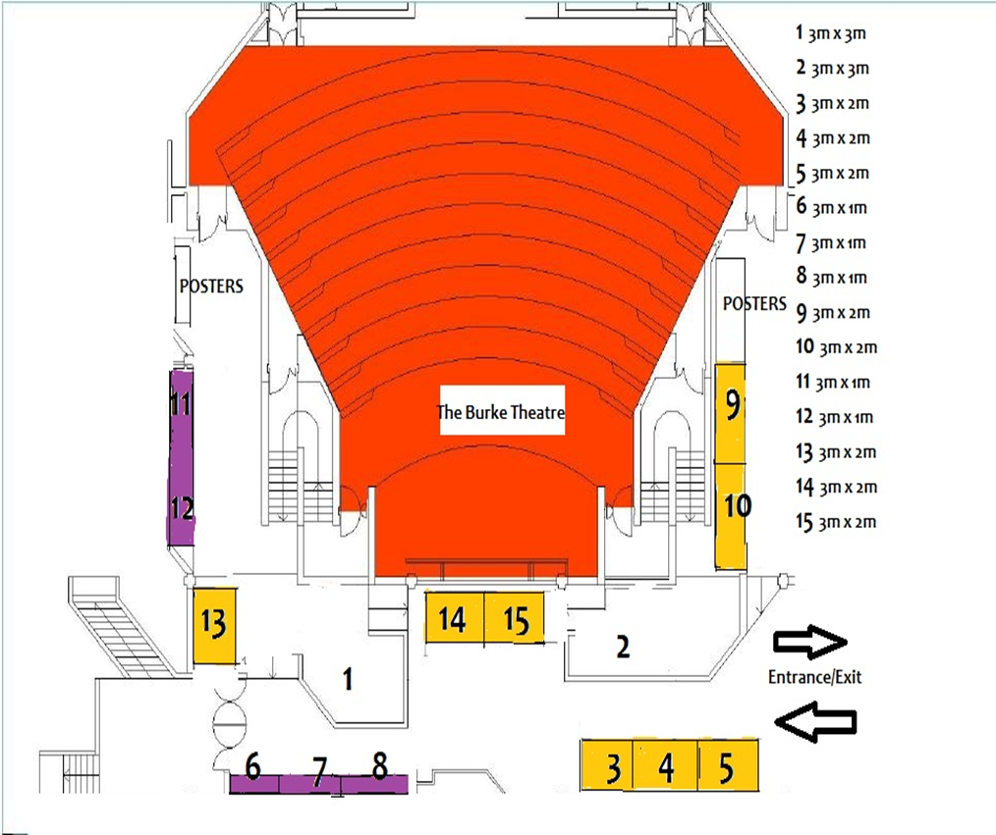

NAPICU is delighted to announce that the 2017 Annual Conference will take place in Trinity College, Dublin Ireland.
This is the first time we have ventured overseas and we hope that we can encourage you to book your stand early and make arrangements to travel to Dublin.
We firmly believe that by going to Dublin we will attract clinicians from Ireland and more from Northern Ireland to attend, thus allowing you to explore a new market for your products.
We will of course continue to deliver the high scientific standard at the conference set in the traditional setting of Trinity College and we are anticipating a conference with delegate numbers in the region of previous years.

Exhibition Space

Exhibition spaces are located in the Lower Concourse on the ground floor of the Art’s Building.

The exhibition spaces are 3m x 1m or 3m x 2m and are priced at £2, 900.00 plus VAT or £2,000.00 plus VAT respectively.

There are two large stands available at 5m x 2m in their own designated area priced at £3, 350.00 plus VAT.

All exhibition packages include:
- Access to 200+ conference delegates
- Two complimentary tickets to the gala dinner
- Your logo will be included on all printed material
- An option to provide a delegate bag insert
- A 10 minute meet & greet session with a member of the NAPICU Executive Committee

Please see the floor plan on page 4 for stand locations.

Please note that exhibition spaces are available on a first come, first served basis.

Exhibition Furniture

Tables and chairs and power sockets can be ordered free of charge for the duration of the meeting. Please indicate your requirements on the booking form. Please note that these tables are not heavy duty and cannot therefore support heavy or large objects.

Poster boards (2.0m high by 1.0m wide) are available at a cost of £50.00 for the duration of the meeting. Please indicate your requirements on the booking form.

Payment Terms

A non-refundable deposit of £500 must be submitted along with the completed form to secure your booking. Bookings made without payment or invoice details will not be considered complete.

Final Payment must be received by Monday 1st August 2017. An invoice will be sent for the full balance upon booking.
Payment can be made by cheque, credit cards or BACS transfer. All payments by BACS transfer must be accompanied by a remittance advice notice sent by e-mail to info@napicu.org.uk

Please note AMEX credit cards cannot be accepted.

Cancellation Terms

Cancellation of Registration by Exhibitor - It is a condition of this booking that notification of cancellations and requests for refund should be made in writing to Northern Networking Events Ltd. For cancellations received before 1st August 2017, 80% of the total remittance (not including £500 non-refundable deposit) will be refunded. Cancellations received on or after 1st August 2017 and prior to 31st August 2017, 50% of the total remittance (not including £500 non-refundable deposit) will be refunded. Fees will not be refunded after 31st August 2017.

Cancellation of Conference/Alteration to Conference – It is a condition of this booking that Northern Networking Events Ltd and/or its Agents have the right for any reason beyond their control to alter or cancel, without prior notices, the Conference or any of the arrangements, timetables, plans or other items relating directly or indirectly to the Conference and that Northern Networking Events Ltd and/or its Agents shall not, subject as aforementioned, be liable for any loss, damage, expenditure or any inconvenience caused as a result of such alteration or cancellation and in the event of cancellation of the Conference the pre-paid delegate registration fees will be returned in full and Northern Networking Events Ltd and/or its Agents shall not be liable for any loss, damage, expenditure or inconvenience caused as a result of such cancellation.

Stand Approval

Any exhibitor wishing to bring a self-build stand for this Conference should provide drawings in advance for approval by the NAPICU Administration office. Please note all self-build stands are also subject to approval by the venue prior to the event. Should any stand be found to be breaching Health and Safety regulations on the day the exhibitor will be asked to amend the issue prior to the exhibition opening.

Internet/Wifi

WiFi is available in the exhibition area and accommodation for delegates and sponsors, a wifi code must be signed for at the registration desk.

Sponsorship/ Exhibitors Recognition

All sponsors and exhibitors will be acknowledged in the Online Abstract/Programme Book and in the Programme at a Glance with an advertising logo where appropriate.

Delivery of Equipment and Access to Trinity College, Dublin

Deliveries for the exhibition must be communicated in advance. You will be advised of the correct delivery address/details that are to be included on the address label and storage arrangements, if needed, subject to availability. All reasonable endeavours for the safekeeping of these items will be taken.

However, they remain at your own risk and Trinity College and NAPICU will not be held responsible in the event of any loss or damage.

Exhibition Protocol

Exhibitors Public and Employers Liability
In accordance with Trinity College’s Terms and Conditions all exhibitors must carry both employers and public liability to cover their activities whilst onsite. It is requested that public liability to be a minimum limit of indemnity of £5,000,000 and employer’s liability insurance to be a minimum limit of indemnity of £10,000,000.

Electrical Safety and Portable Appliance Testing
It is vital to ensure that electrical equipment brought onto site by all exhibitors has been thoroughly inspected to ensure that it is properly earthed, fused and cannot become a risk. Any equipment not PAT tested may be removed. Please note laptops, PCs and plasma TV’s are not required to be PAT tested but will be visually checked. Power leads for PCs etc will need to be tested.
Please note there are limits on the amount of power that can be drawn from one socket, and adding too many pieces of equipment onto one socket could cause an overload of the system. A visual check will be done on the day to ensure the limits are adhered to, please ensure you request the correct amount of sockets for the amount of equipment being used.

Important Dates Summary

4th September 2017 250 delegate bags inserts to be delivered directly to the NAPICU Administrative Office at Trinity College, (please ensure you allow time for delivery)

5th September 2017 All deliveries for your stand should be made to Trinity College

All stands should be fully built between times to be confirmed

7th September 2017 Registration for the main conference opens
Poster and Exhibition Lunch

8th September 2017 Exhibition breakdown
All stands must be dismantled and packed by time to be confirmed

Exhibition Booking Form 2017
Company:
Main Contact:
Stand Person(s):
Address:
Tel: |  |  |  |  | Fax: |  |  |  |  | Email:
Accommodation is available within student halls of residence for £80 plus VAT B&B per night
I will require accommodation for the following:
Wednesday 7th September |  |  |  | □ |  |  | Thursday 8th September |  |  |  |  | □
Please state who the rooms should be booked for:
Please select one of the below options:

Exhibition Space |  |  |  |  |  | Cost* |  |  |  |  | Stand Number |  |  |  | Total Cost
Exhibition Space (5m x 2m) |  |  |  |  |  | £3350.00
Exhibition Space (3m x 2m) |  |  |  |  |  | £2900.00
Exhibition Space (3m x 1m) |  |  |  |  |  | £2000.00
*Please note all prices quoted are excluding VAT
Exhibition spaces are available on a first come, first serve basis
Sundries |  |  |  |  |  | Cost |  |  |  |  | Quantity |  |  |  | Total Cost
Poster Board |  |  |  |  |  | £50
Table (max 1) |  |  |  |  |  | Free |  |  |  |  |  |  |  |  | Free
Chair (max 3) |  |  |  |  |  | Free |  |  |  |  |  |  |  |  | Free
Power Point |  |  |  |  |  | Free |  |  |  |  |  |  |  |  | Free
Gala Dinner Tickets |  |  |  |  |  | 2 complimentary  Additional – £75.00
 |  |  |  |  |  |  |  |  |  |  | Grand Total

Sponsorship Opportunities (please tick as appropriate)

Sponsorship Items | Cost | 1st Choice | 2nd Choice
Delegate Bags | Supplied by you in agreement with NAPICU
Pens | Supplied by you in agreement with NAPICU
Pads | Supplied by you in agreement with NAPICU
Programme Book Advert (Colour) | £500.00
Programme Book Advert (B&W) | £350.00
Gala Dinner Wine | £300.00
Gala Dinner Entertainment | £500.00
Tea/Coffee Breaks  Please specify session: __________________ | £150.00 per session
Delegate Bag Insert | £150.00 + VAT
General Sponsorship (at discretion)  Please specify amount: _________________ | Min. £100.00
 | If you have any special requirements please specify below:
Invoice Details (if different from above):
Company:
Contact:
Purchase Order:
Address:
Tel: |  |  |  | Fax: |  | Email:
I have sent a copy of our company logo to be used in all promotional literature
I agree to the payment terms as outlined on page 1&2
Signed:
Date:

