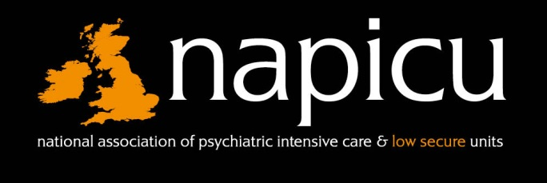
22nd Annual NAPICU Conference
Trinity College, Dublin, Ireland
7th – 8th September 2017
Registration Form

Personal Details

Family Name: |  |  |  |  |  |  |  |  | Title (Prof/Dr/Mr/Ms/Other)
First Name: |  |  |  |  |  |  | Name for Badge:
Trust/Organisation:
Ward: |  |  |  |  |  | Address:
City: |  |  |  | County: |  |  |  | Postcode: |  |  | Country:
Phone: |  |  |  | Fax: |  |  |  | Email:
I do not wish for my details to appear on the delegate list (please tick if applicable)
Registration Fees
On/Before 1st August 2017 | Member* | No. | Non-Member | No. | Sub-Total
Early bird conference delegate rate | £455 |  | £555
Early bird conference group rate for 6 ward members (saving £55 pp) | £2400 |  | N/A
Early bird conference & training event | £535 |  | £635
Early bird conference & training group rate for 6 ward members | £2880 |  | N/A
After 1st August 2017
Conference delegate rate | £505 |  | £615
Conference group rate for 6 ward members  (saving over £20 pp) | £2900 |  | N/A
Conference & training event | £585 |  | £695
Conference & training group rate for 6 ward members | £3380 |  | N/A
A limited number of student places are available, for more information please contact the admin office on the details below. |  |  |  | Total

Accommodation & Social Event – conference accommodation is now sold out.
*Please note: If your 2017/18 Membership dues are not paid by 1st August 2017, you will be charged the non-member rate

I wish to attend the Gala Dinner on Thursday 7th September |  | Yes |  | No
Special Dietary/Access Requirements
22nd Annual NAPICU Conference
Trinity College, Dublin, Ireland
7th – 8th September 2017

Breakout Session Selections
Please indicate below which session you wish to attend () including a reserve choice (R). Places on each session will be allocated on a first come first serve basis. Please see the programme online for full choice listings. Please note that this year delegates should select one breakout session only.
Thursday 7th September 12.25 – 13.15
(please tick your first choice () and indicate your reserve with “R”)
Session 1 |  | Session 2 |  | Session 3 |  | Session 4 |  | Session 5 |  | Session 6
Session 7
If you require an invoice please complete the section below:
Name: |  |  |  |  |  |  | Purchase Order No:
Address:
Postcode: |  |  |  |  | Email: |  |  | Phone:
To pay by card please complete section below (Amex not accepted)
Card Number
Expiry Date (MM/YYYY): |  |  |  |  |  |  |  |  |  | Security Code (last 3 digits):
Cardholder’s Signature: |  |  |  |  |  |  |  |  |  |  |  |  | Date:
Payment Details
Secure on-line registrations & payment can be made for individual bookings only on the website – www.napicu.org.uk and completing the registration. We cannot accept online payment with Amex. You will receive an automatic confirmation of payment and we will send you a separate receipt and details of how to get to the venue.

Cancellation of registration by Delegate – it is a condition of this booking that notification of cancellations and requests for refund should be made in writing to Northern Networking Events Ltd. For cancellations received before 8th August 2017, 80% of the total remittance will be refunded. Cancellations received on or after 1st August 2017 and prior to 22nd August 2017 50% of the total remittance will be refunded. Fees will not be refunded after 31st August 2017. Substitute names can be made at no extra cost but must be made in advance in writing.

Cancellation of Conference/Alteration to Conference – it is a condition of this booking that Northern Networking Events Ltd and/or its agents have the right for any reason beyond their control to alter or cancel, without prior notices, the conference or any of the arrangements, timetables, plans or other items relating directly or indirectly to the Conference and that Northern Networking Events Ltd and/or its agents shall not, subject as aforementioned, be liable for any loss, damage, expenditure or any inconvenience caused as a result of such alteration or cancellation and in the event of cancellation of the Conference the pre-paid delegate registration fees will be returned in full and Northern Networking Events and/or its agents shall not be liable for any loss damage, expenditure or inconvenience caused as a result of such cancellation.
Please tick to confirm you have read and understood the above terms and conditions ☐

