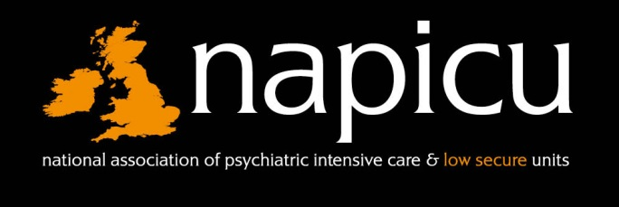

20th & 21st March 2019
Peterhouse College, Cambridge,
CB2 1RD

Registration Form

THE MULTIDISCIPLINARY MANAGEMENT OF ACUTE DISTURBANCE

Personal Details

Family Name: |  |  |  |  |  |  |  |  | Title (Prof/Dr/Mr/Ms/Other)
First Name: |  |  |  |  |  |  | Name for Badge:
Trust/Organisation:
Ward Name: |  |  |  |  |  | Address:
City: |  |  |  | County: |  |  |  | Postcode: |  |  | Country:
Phone: |  |  |  | Fax: |  |  |  | Email:
I do not wish for my details to appear on the delegate list (please tick if applicable)

Registration Fees

 | Member* | No. | Non-Member | No. | Sub-Total
Registration with dinner on the evening of 20th March | £420 |  | £490
Registration without dinner | £350 |  | £420
*Member rate: To qualify for this you must be a paid member of NAPICU or BAP for the current membership year |  |  |  | Total

Accommodation:
The Hotel Centennial is approx. 15 mins walk from the venue and we have agreed a fantastic rate of £105 B&B per night. To receive this price call the hotel on 01223 314652 or email reception@centennialhotel.co.uk to make your reservation. All guests will need to quote ‘NNE’. Please see hotel website for more details. www.centennialhotel.co.uk
Centennial Hotel
63-71 Hills Road
Cambridge
CB2 1PG
Tel: 01223
20th & 21st March 2019
Peterhouse College, Cambridge, CB2 1RD

Payment Details

If you require an invoice please complete the section below:
Name: |  |  |  |  | Purchase Order No:
Address:
Postcode: |  |  | Email: |  |  | Phone:
To pay by card please complete section below (Amex not accepted)
Card Number
Expiry Date (MM/YYYY): |  |  |  |  |  |  |  |  |  | Security Code (last 3 digits):
Name of Card:
Cardholder’s Signature:
Secure on-line registrations & payment can be made for individual bookings only on the website – www.napicu.org.uk and completing the registration. We cannot accept online payment with Amex. You will receive an automatic confirmation of payment and we will send you a separate receipt and details of how to get to the venue.

Cancellation of registration by Delegate – it is a condition of this booking that notification of cancellations and requests for refund should be made in writing to Northern Networking Events Ltd. For cancellations received before 15th February 2019, 80% of the total remittance will be refunded. Fees will not be refunded after 15th February 2019. Substitute names can be made at no extra cost but must be made in advance in writing.

Cancellation of Conference/Alteration to Conference – it is a condition of this booking that Northern Networking Events Ltd and/or its agents have the right for any reason beyond their control to alter or cancel, without prior notices, the conference or any of the arrangements, timetables, plans or other items relating directly or indirectly to the Conference and that Northern Networking Events Ltd and/or its agents shall not, subject as aforementioned, be liable for any loss, damage, expenditure or any inconvenience caused as a result of such alteration or cancellation and in the event of cancellation of the Conference the pre-paid delegate registration fees will be returned in full and Northern Networking Events and/or its agents shall not be liable for any loss damage, expenditure or inconvenience caused as a result of such cancellation.
Please tick to confirm you have read and understood the above terms and conditions ☐

