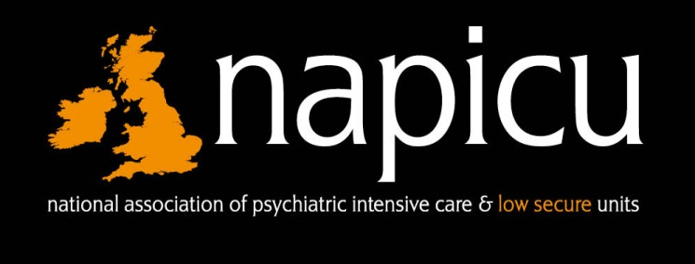
24th Annual NAPICU Conference
Thursday 5th – Friday 6th September 2019
Glasgow Caledonian University

Speaker Abstract Submissions

The NAPICU Conference Committee invites you to apply to speak at the 24th NAPICU Annual Conference on Thursday 5th September 2019 during a parallel session, you would be one of 3 speakers and have a 20 minute slot.

The conference theme is:

Therapeutic Advancements In Acute, Emergency And Secure Mental Health Settings; Reducing Restrictive Interventions

Speaker abstract submissions can be made for the following sessions:

Parallel 2: Therapeutic Practice in Different Settings (Secure/Low secure/Community)
Chair: Wendy Sherwood, Consultant Occupational Therapist, International Creative Ability Network and NAPICU Executive Committee Member.
Or

Parallel 3: Education and Workforce (Education and training in a PICU setting/ Responding to workforce challenges/ Involving patients and carers in training)
Chair: Aileen O’Brien, Reader in Psychiatry & Education and Honorary Consultant Psychiatrist (PICU), St. George’s University of London and NAPICU Director of Educational Programmes.
Selection Criteria
A multi-disciplinary panel of judges will consider the applications. Each abstract will be judged on objective evidence on the following criteria (meeting all the criteria is not required):
- Relevant to PICU or a low secure setting
- Compliments the conference theme of reducing restrictive practice
- High quality practice/research which is safe, effective, timely, efficient and equitable.
- Innovative practice/research that has positive impacts on optimising patient-centred care.
- Commitment to delivering evidence based practices
- Engagement of patient/carers
- Demonstrate positive learning outcomes and future learning points
Please note delegates will be asked for feedback on each speaker, feedback is marked in the following areas: Content, Presentation and Usefulness, please consider this when submitting your abstract. In previous feedback delegates have requested ‘key points to take home’ relating to their practice of PICU and Low Secure.

Speaker Abstract Submission Form 2019
How to Submit an abstract
All applications should be submitted electronically by email to the NAPICU Administration Office info@napicu.org.uk
Closing date for receipt of abstracts is Sunday 31st March 2019.
NB. It is the applicants’ responsibility to ensure that their submission has been received by the NAPICU Administration Office by the deadline.
A multi-disciplinary panel of judges will consider the applications and successful speakers will be contacted by Friday 19th April 2019.
Unsuccessful applications will be encouraged to present their submission as a poster format following the NAPICU poster application guidance. Closing date for receipt of poster entries is Friday 26th July 2019
Please complete the form below:
Family Name: |  |  |  |  |  |  |  |  | Title (Prof/Dr/Mr/Ms/Other)
First Name: |  |  |  |  |  |  | Job Title:
Trust/Organisation:
Ward: |  |  |  |  |  | Address:
City: |  |  |  | County: |  |  |  | Postcode: |  | Country:
Phone: |  |  |  | Mobile: |  |  |  | Email:

Speaker Abstract Submission Form 2019 Cont…

Parallel Session (please tick) | Parallel 2: Therapeutic Practice in Different Settings | Parallel 3: Education and Workforce
Presentation Title
Abstract (maximum 250 words)
Learning outcomes  (state 3) | Delegates will:
Presenter(s) biography (maximum 100 words per presenter)
If unsuccessful would you be willing to present the submission as a poster (following NAPICU poster guidance) | Yes | No
NAPICU Administration Office
Scottish Enterprise Technology Park, 2nd Floor, Nasmyth Building, 60 Nasmyth Avenue, East Kilbride, G75 0QR
T: 01355 244 585 E: info@napicu.org.uk

