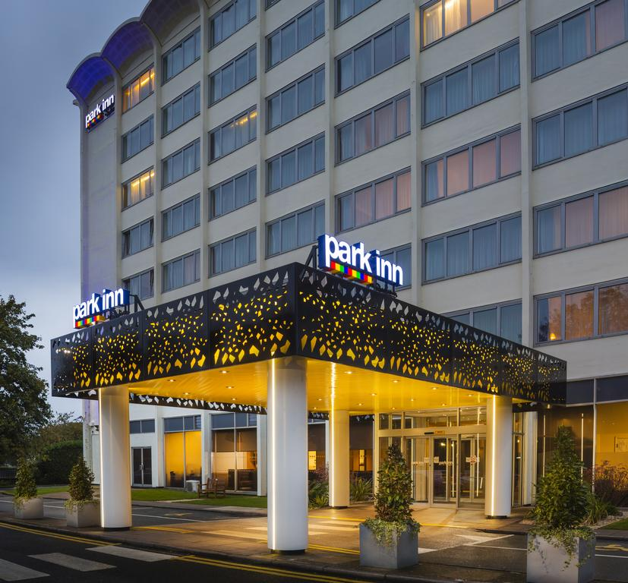
22nd– 23rd September, Northampton
NAPICU 25th ANNUAL CONFERENCE 2022

Sponsorship Brochure

NAPICU Regular Sponsors are already making NAPICU 25th Annual Conference part of their marketing schedule for 2022.

For 25 years, NAPICU Conferences has attracted a growing number of attendees due to our specialised training, unique networking opportunities and memorable social programme, so this said as NAPICU celebrate 25 years with our annual conference NAPICU 2022 will assuredly be a memorable and rewarding experience for both first-time and returning exhibitors and sponsors.

Choose from one of our superb value packages or call us for a bespoke package. We also have many opportunities for you to promote your brand, engage with delegates and connect with other sponsors throughout the two days.

Why Sponsor?
- To have direct access to some of the key decision-makers in public and private mental health organisations
- Be first to hear about NAPICU opportunities before others in your industry
- Reach NAPICU members, partners and service users
- Share best practices with peers during networking opportunities

Exhibition and Sponsorship sell out quickly. Sign up now by completing the last page in this brochure, or for more information, please contact: Klaudia Knedel at info@napicu.org.uk

We hope you will join us to celebrate 25 years of NAPICU in Northampton in September 2022!

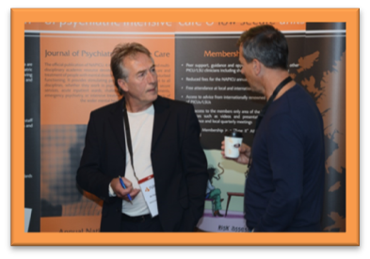

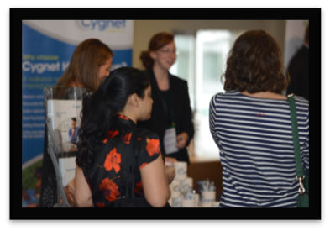
PREVIOUS DELEGATE INFORMATION
NAPICU Conferences have attracted a growing number of attendees due to our specialised training, unique networking opportunities and memorable social programme. With our unique multidisciplinary position, our conferences attract those who make decisions and the dedicated staff who work face to face with the service users.

YEAR | LOCATION | DELEGATE NUMBERS
2019 | GLASGOW | 282
2018 | LOUGHBOROUGH | 258
2017 | DUBLIN | 297

SPONSORSHIP INFORMATION
NAPICU 25th Annual Conference 2022 will be held at Radisson Park Inn, Northampton. As this year is such a benchmark for NAPICU success and expected to be such a celebration that we anticipate a high number of delegates from trusts and organisations across the world.

PLATINUM SPONSOR: £6250
- Premium space includes 4m x 2m stand
- Electricity points and wireless internet
- Two full conference passes for guest
- Two exhibitor passes
- Four Gala Dinner Tickets for guests & exhibitors
- Signage designating platinum sponsorship
- Recognition on NAPICU conference website
- Inclusion of four social media posts sent from NAPICU channels
- Logo and 250-word description on mobile app
- Website link on NAPICU app & webpage
- Delegate bag insert in the Conference bag
- Company advert inserted into the Journal of Psychiatric Intensive Care and the NAPICU website
- Company logo displayed on the dedicated sponsor’s board at the venue
- Accommodation & catering

GOLD SPONSOR: £4415
- Premium space includes 3m x 2m stand
- Electricity points and wireless internet
- One full conference passes for guest
- Two Exhibitor passes
- Three Gala Dinner Tickets for guest & exhibitors
- Signage designating gold sponsorship
- Recognition on NAPICU conference website
- Inclusion of three social media posts sent from NAPICU channels
- Logo and 100-word description on mobile app
- Website link on NAPICU app & webpage
- Delegate bag insert in the Conference bag
- Company logo displayed on the dedicated sponsor’s board at the venue
- Accommodation & catering
SILVER SPONSOR: £3500
- 2m x 1m stand
- Electricity points and wireless internet
- Two exhibitor passes
- Two Gala Dinner Tickets for exhibitors
- Signage designating silver sponsorship
- Recognition on NAPICU conference website
- Inclusion of one social media posts sent from NAPICU channels
- Logo on mobile app
- Delegate bag insert in the Conference bag
- Company logo displayed on the dedicated sponsor’s board at the venue
BRONZE SPONSOR: £2500
- 2m x 1m stand
- One Exhibitor pass
- One Gala Dinner Ticket for exhibitor
- Recognition on NAPICU conference website
- Inclusion of one social media posts sent from NAPICU channels
- Logo on mobile app
- Company logo displayed on the dedicated sponsor’s board at the venue

*Please note all prices quoted are
*All prices are exclusive of VAT at the prevailing rate, Sponsorship items are available on a first-come, first-served basis x 1m stand
Sponsor’s board at the venue

ADDITIONAL SPONSORSHIPS OPPORTUNITIES
Additional opportunities are available to be the designated sponsor for a number of other items.

INTERNATIONAL DELEGATE SPONSORSHIP: £500 + travel expenses (per delegate)
- Entitles 1 International delegate (from lower income country) full residential registration
- Logo displayed at NAPICU Conference
- Logo & recognition on the programme

INTERNATIONAL DELEGATE SPONSORSHIP: £2,250+ travel expenses (5 delegates)
- Entitles 10 International delegates (from lower income country) full residential registration
- Logo displayed at NAPICU Conference
- Large Logo & recognition on the programme

PROGRAMME AT A GLANCE: £625
- One sponsorship available
- Large Logo & recognition on the programme

DELEGATE BAG SPONSOR: £1250
- One sponsorship available
- Capture the attention of conference attendees as the exclusive delegate bag sponsor.
- Your logo will be displayed on the bags that the delegates receive at registration and will carry with them throughout the conference
- Includes one bag insert.

PEN SPONSOR: £150 (supplied by sponsor)
- One sponsorship available

NOTEPAD SPONSOR: £150 (supplied by sponsor)
- One sponsorship available

DELEGATE BAG INSERT: £250
- Inclusion of company material in every delegate bag

NETWORKING DRINKS: £415
- One sponsorship available
- Signage at Networking Drinks
- Branded cocktail napkin* with your company logo
- Tent cards on all tables
- Promotion on the conference website

TEA & COFFEE SPONSOR: £350
- Two sponsorships available (Thursday or Friday)
- Branded cocktail napkin* with your company logo
- Signage announcing sponsorship

QUIZ NIGHT SPONSOR: £350
- One sponsorship available
- Branded cocktail napkin* with your company logo
- Signage announcing quiz sponsorship

GALA DINNER SPONSOR: £750
- One sponsorship available
- Branding at the gala dinner & on menu
- Signage announcing sponsorship
- Promotion on the conference website

BESPOKE SPONSORSHIP:
We will work together to design the package that best suits your agenda and budget. Examples:
- Thermal Flasks (Supplied by Sponsor) £150
- Water bottle (Supplied by Sponsor) £150
- T-shirts 200 (Supplied by Sponsor) £3750

LOGO PACKAGES: (prices on request)
- Multiple available - Graphics to be supplied by sponsor.
- Logo on NAPICU app & Website
- Logo and description on NAPICU app & website

GENERAL DONATION – over £1,000
- Logo displayed at NAPICU Conference
- Logo displayed at the conference and full online presence.

FOR ADDITIONAL INFORMATION
Regarding Sponsorship opportunities please contacts: Klaudia Knedel at info@napicu.org.uk

* Subject to Change
*Please note all prices quoted are exclusive of VAT at the prevailing rate, Sponsorship items are available on a first-come, first-served basis

SPONSORSHIP LEVELS AT A GLANCE

SPONSOR SUMMARY | PLATINUM | GOLD | SILVER | BRONZE
Stand Size | 4m x 2m | 3m x 2m | 2m x 1m | 2m x 1m
Electricity Points | ✔ | ✔ | ✔
Company Logo Displayed On The Dedicated Sponsor’s Board At The Venue | ✔ | ✔ | ✔ | ✔
Conference Pass for guest | ✔ | ✔
Gala Dinner Tickets | ✔ | ✔ | ✔ | ✔
Signage Designating Sponsorship Level | ✔ | ✔ | ✔
Recognition On Napicu Conference Website | ✔ | ✔ | ✔ | ✔
Social Media Posts Sent From Napicu Channels | ✔ | ✔ | ✔ | ✔
Logo On Mobile App | ✔ | ✔ | ✔ | ✔
Sponsor Description On App | ✔ | ✔
Website Link On Napicu App | ✔ | ✔ | ✔
Website Link On Napicu Webpage | ✔ | ✔
Delegate Bag Insert In The Conference Bag | ✔ | ✔ | ✔
Company Advert Inserted Into The Journal Of Psychiatric Intensive Care | ✔
Accommodation & Catering | ✔ | ✔

LOCATION
The exhibition space will be in the Buckingham Suite Foyer, Radisson Park Inn, Northampton which will form the hub of the conference, this provides an excellent opportunity for delegates to network with the exhibitors and familiarise themselves with the latest advances in technology, furniture and private healthcare organisations. Delegates increasingly welcome the opportunity to tap into the expertise provided by exhibitors. In addition to the commercial exhibits, tea and coffee and lunchtime catering will be served in the exhibition area. Wi-fi will be available to all delegates in this area.

NETWORKING OPPORTUNITIES WITHIN THE EXHIBITION HALL
- Tea and coffee breaks/ lunchtime catering for both days
- Interactive Poster, Networking & Exhibition session (Thursday afternoon)
- Exhibition before, after & between every session

EXHIBITION OPENING HOURS*
TBC |  | Exhibition Build Up
TBC |  | Exhibition Open
TBC |  | Exhibition Open
TBC |  | Exhibition Break Down
*These times are approximate and may be subject to change.
SPECIFIC EXHIBITION DETAILS
Further specific exhibition details giving detailed and technical information, advice and full details on all aspects of the exhibition, and venue instructions will be circulated in early autumn 2022. This will be followed by Exhibitor Joining Instructions in September 2022 before the Conference commencing.
EXHIBITION FURNITURE
Tables and chairs can be ordered free of charge for the duration of the conference. Please note that these tables are not heavy duty and cannot, therefore, support heavy or large objects.
Please indicate your requirements on the booking form.

STAND APPROVAL
Any exhibitor wishing to bring a self-build stand for this Conference should provide drawings in advance for approval by the NAPICU Administration office. Please note all self-build stands are also subject to approval by the venue before the event. Should any stand be found to be breaching Health and Safety regulations on the day the exhibitor will be asked to amend the issue before the exhibition opening.

EXHIBITION PROTOCOL
ABPI Guidance
All pharmaceutical exhibitors should follow the ABPI guidance - https://www.abpi.org.uk/publications/code-of-practice-for-the-pharmaceutical-industry-2021/

Electrical Safety and Portable Appliance Testing

It is vital to ensure that electrical equipment brought onto site by all exhibitors has been thoroughly inspected to ensure that it is properly earthed, fused and cannot become a risk. Any equipment, not PAT tested may be removed. Please note there are limits on the amount of power that can be drawn from one socket and adding too many pieces of equipment onto one socket could cause an overload of the system. A visual check will be done on the day to ensure the limits are adhered to; please ensure you request the correct amount of sockets for the amount of equipment being used. Please note that risk assessments may be required in due course.

ACCOMMODATION
Accommodation and catering are only included in some of the sponsorship packages. Accommodation can be arranged through the NAPICU admin office for an additional fee. Accommodation will be available either at the exhibition hotel or at a lower cost at hotels in the locality. NAPICU cannot guarantee accommodation, it will be offered on first come first served basis.

EXHIBITION FLOOR PLAN
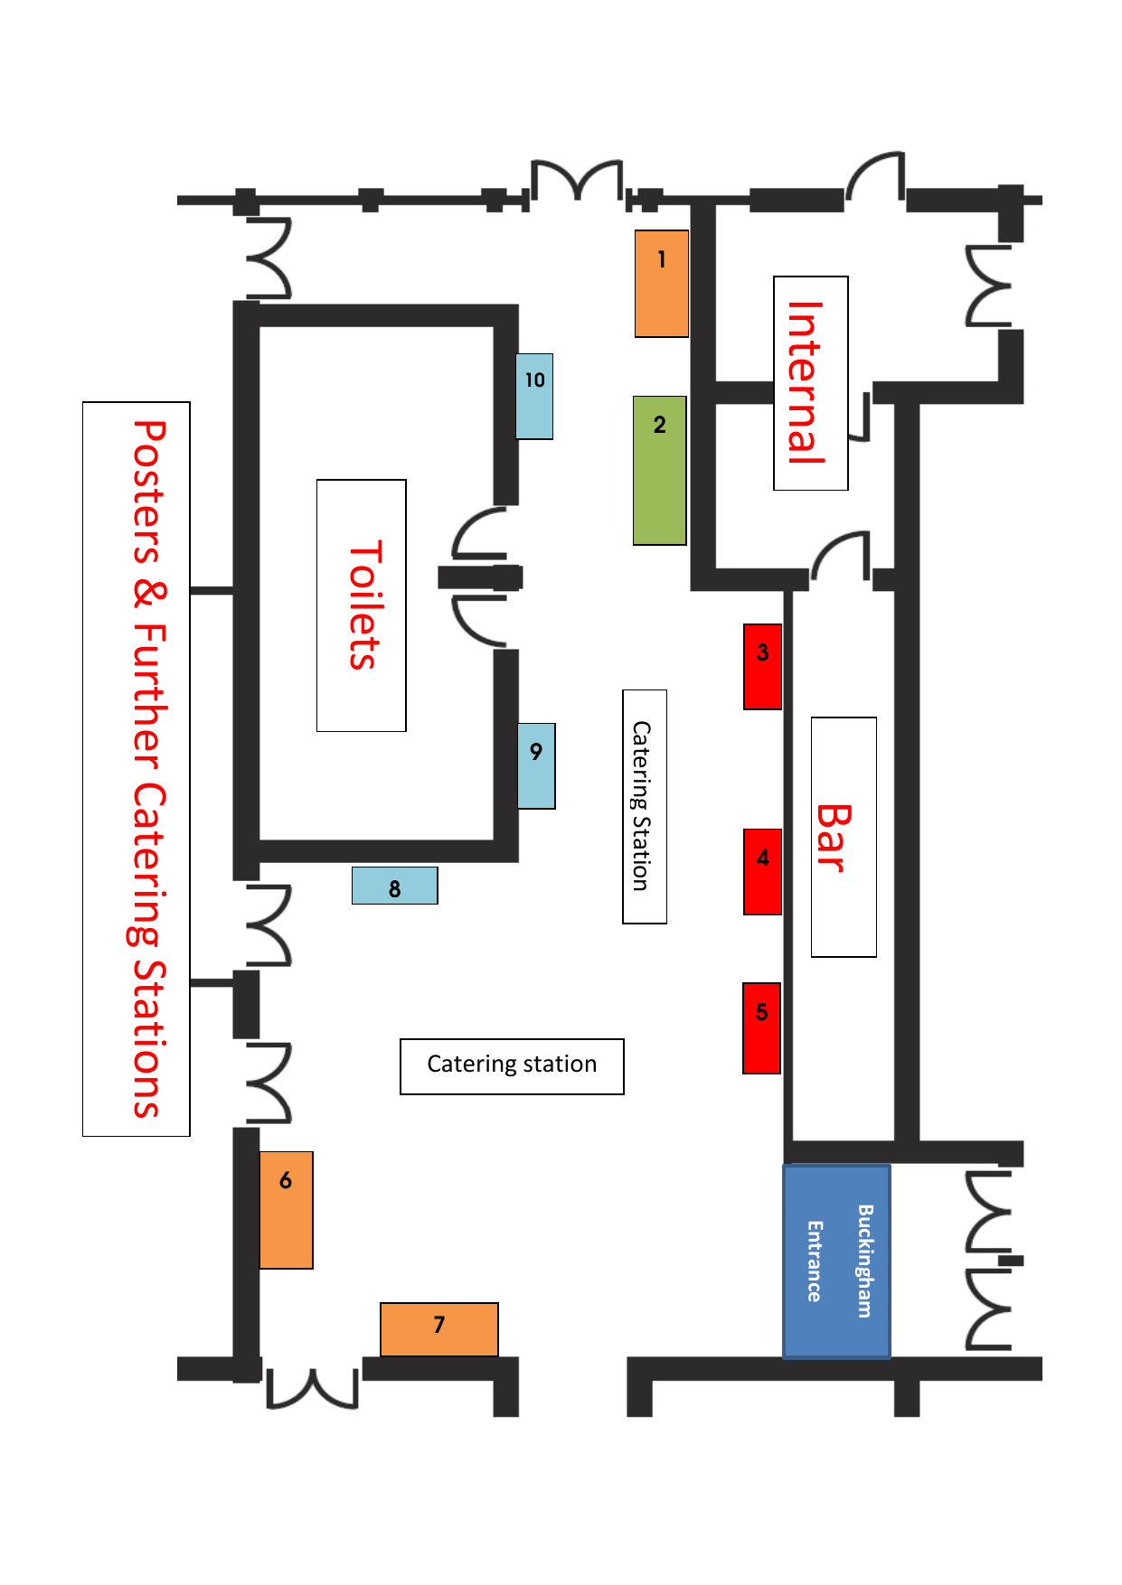
SOLDOLDD
SOLDOLDD
SOLD
SOLDOLDD
*
*Entrance to main lecture theatre
Legend
 | 4x2m Stand |  |  | 3x2m Stand
 | 2x1m Stand |  |  | 2x1m Stand (these stands will be moved during the gala dinner event)

BOOKING FORM
Company
Main Contact
Stand Person(s)
Address
Tel |  | Email
Table Required |  |  | No of Chairs required

Please select one of the below options:
Sponsorship Package | Cost* | Stand Number | Tick to Select
Platinum Package | £6250
Gold Package | £4415
Silver Package | £3500
Bronze Package | £2500

Sponsorship Item | Price | Tick to select
International Delegate – 1 delegate | £500 + expenses
International Delegate – 5 delegates | £2,250+ expenses
Programme at a Glance | £625
Delegate Bags | £1250
Pens (Supplied by Sponsor) | £150
Delegate Bag Insert | £250
Notepads (Supplied by Sponsor) | £150
Tea and Coffee Sponsor | £350
Networking Drinks | £415
Gala Dinner Sponsor | £750
Quiz Night Sponsor | £350
Thermal Flasks (Supplied by Sponsor) | £150
Water Bottles (Supplied by Sponsor) | £150
T-shirts (Supplied by Sponsor) | £3750
General Donation | £1000 +

A deposit of £500 is required at the time of booking to secure the booking and preferred stand number.
By submitting this registration form you are agreeing with the terms and conditions below

*Please note all prices quoted are exclusive of VAT at the prevailing rate. Exhibition spaces are available on a first-come, first-served basis.

TERMS AND CONDITIONS OF AGREEMENT
This Sponsorship Contract (the “Contract”) is entered into this day (“Effective Date”), by and between NAPICU (Northern Networking Event Ltd (NNE) working as agents of NAPICU) and Company. By signing this Contract, the Company agrees to comply with the terms and conditions set forth below. This Contract shall become binding upon acceptance by an authorized NAPICU representative for the NAPICU Conference 2022.
RECITALS
- WHEREAS NAPICU plans to conduct a Conference in Northampton in September 2022 (“NAPICU Conference”), and
- WHEREAS, Company desires to sponsor or exhibit at the Users Conference under the sponsorship/exhibition package as outlined in the registration form in exchange for certain promotional consideration, and
- WHEREAS, NAPICU desires to accept such sponsorship or exhibition participation.

NOW, THEREFORE, for good and valuable consideration, the sufficiency of which both parties hereby acknowledge, the parties agree as follows:

- SPONSORSHIP / EXHIBITION PACKAGE
Company hereby elects to be a sponsor/exhibitor of the Conference under the sponsorship/exhibition package as outlined in the registration form (“sponsorship/exhibition package”).
- USE OF COMPANY MATERIALS
  - License Grant. Company hereby grants to NAPICU a nonexclusive, non-transferable, license, solely for the term of this Contract, to use the trademarks, trade names, logos, identifying marks, and URLs, as described on the sponsorship brochure (the “Marks”), for use by NAPICU in connection with presentation of the Conference, including promotional materials, and in fulfilment of NAPICU’s obligations hereunder and such right, shall automatically terminate upon completion of the Sponsorship or termination of this Contract, whichever is earlier. NAPICU shall also comply with the Company’s logo usage guidelines.
  - Reservation of Rights. NAPICU acknowledges that Company owns and retains all rights associated with the Marks and that any and all goodwill derived from the use of the Marks hereunder inures solely to the benefit of the owner of the Marks.

- OBLIGATIONS OF THE PARTIES
  - NAPICU. NAPICU hereby agrees to provide Company with the promotional services and materials, consistent with the Company’s sponsorship/exhibition package, as outlined in the sponsor brochure).
  - Company. In addition to payment obligations hereunder, Company agrees to provide NAPICU with the Marks listed in the sponsorship brochure, in the format and via media as reasonably requested by NAPICU.
  - Cooperation of the Parties. The parties agree to cooperate and provide reasonable assistance, as requested by the other party, in the performance of the obligations set forth herein.

- CONFERENCE SCHEDULING
  - Schedule Changes. If NAPICU changes the site, hours or dates of the Conference NAPICU will notify Company of any such changes in writing as far in advance as possible.
  - Cancellation by NAPICU: NAPICU reserves the right to cancel the Conference, in whole or in part, or to terminate this Contract for any reason, with or without cause, at any time upon written notice to Company. It is a condition of this booking that Northern Networking Events Ltd and/or its Agents have the right for any reason beyond their control to alter or cancel, without prior notices, the Conference or any of the arrangements, timetables, plans or other items relating directly or indirectly to the Conference and that Northern Networking Events Ltd and/or its Agents shall not, subject as aforementioned, be liable for any loss, damage, expenditure or any inconvenience caused as a result of such alteration or cancellation and in the event of cancellation of the Conference the pre-paid delegate registration fees will be returned in full and Northern Networking Events Ltd and/or its Agents shall not be liable for any loss, damage, expenditure or inconvenience caused as a result of such cancellation.

  - Cancellation by Company: It is a condition of this booking that notification of cancellations and requests for refund should be made in writing to Northern Networking Events Ltd. For cancellations received before Monday 3rd August 2022, 70% of the total remittance (not including £500 non-refundable deposit) will be refunded. Fees will not be refunded after Monday 3rd August 2022.

- FEES; PAYMENT
  - Fees. Company agrees to pay NAPICU the fees specified for the Company’s sponsorship/exhibition package, as outlined in the Sponsorship brochure (“Fees”).
  - Payment. Payment of the Company’s Sponsorship Fees; A non-refundable deposit of £500 must be submitted along with the completed registration form to secure your booking. Bookings made without payment or invoice details will not be considered complete. Full payment is then due NET 30 days from receipt of invoice and no later than Monday 3rd August 2022. Payment shall be made in pounds (GBP) by BACS, cheque or credit card. All BAC payments must be accompanied by a remittance advice notice sent by email to info@napicu.org.uk.
NB. Amex credit cards cannot be accepted

- WARRANTY; DISCLAIMER
Company acknowledges that all services and materials provided by NAPICU in connection with this Contract are being provided “AS IS.” NAPICU DISCLAIMS ALL WARRANTIES, EXPRESS OR IMPLIED, INCLUDING THE IMPLIED WARRANTIES OF MERCHANTABILITY, FITNESS FOR A PARTICULAR PURPOSE, AND NON-INFRINGEMENT, AND ANY WARRANTIES ARISING OUT OF COURSE OF DEALING OR USAGE OF TRADE.

- LIMITATION OF LIABILITY
IN NO EVENT SHALL NAPICU BE LIABLE TO COMPANY OR TO ANY THIRD PARTY FOR DAMAGES OF ANY KIND, INCLUDING, WITHOUT LIMITATION, INDIRECT, SPECIAL, INCIDENTAL, PUNITIVE OR CONSEQUENTIAL DAMAGES (INCLUDING LOSS OF USE, DATA, BUSINESS OR PROFITS) ARISING OUT OF OR IN CONNECTION WITH THIS CONTRACT OR FOR ANY ERROR OR DEFECT IN ANY MATERIALS PROVIDED, WHETHER SUCH LIABILITY ARISES FROM ANY CLAIM BASED UPON CONTRACT, WARRANTY, TORT (INCLUDING NEGLIGENCE), STRICT LIABILITY OR OTHERWISE, AND WHETHER OR NOT NICE HAS BEEN ADVISED OF THE POSSIBILITY OF SUCH LOSS OR DAMAGE. THE PARTIES HAVE AGREED THAT THESE LIMITATIONS WILL SURVIVE AND APPLY EVEN IF ANY LIMITED REMEDY SPECIFIED IN THIS AGREEMENT IS FOUND TO HAVE FAILED OF ITS ESSENTIAL PURPOSE. IN NO EVENT SHALL NAPICU’S TOTAL AGGREGATE LIABILITY UNDER THIS CONTRACT EXCEED FEES PAID BY COMPANY TO NAPICU UNDER THIS CONTRACT.
Notwithstanding anything stated to the contrary, each party shall indemnify and hold each other harmless for direct damage liability or loss resulting from death, personal injury or tangible property damage, negligence or wilful misconduct by its personnel or its subcontractors or agents or any other liability that may not be excluded by law.

- DATA PROTECTION
Each party warrants that it complies with all applicable laws and regulations when providing services, especially, without limitation all applicable local data protection laws and/or regulations worldwide, including the EU and its member states.
Each party warrants that during the collection, processing and use of individual personal information, the person to whom the data belongs (the “Data Subject”) has been informed of and consented to:
  - it's right to object at no cost to the collection, processing and/or use of its data
  - the purpose of the collection, processing and/or use of its data
  - its rights to object at no cost to the use of its data for purposes of canvassing in particular for commercial purposes
  - its personal data may be exported to other countries, including outside European Union
  - being contacted by commercial third parties, including NAPICU and its affiliates for marketing and other purposes
Each party warrants that it has the right to grant the licenses and other rights related to the use of personal data, especially without limitation to the extent the processing of personal data has been collected through social public networking platform or others public support.

- GENERAL
  - Force Majeure: NAPICU shall not be responsible for any loss or damage resulting from failure to perform under this Contract or failure to present at the Users Conference, in whole or part as a result of riot, strike, terrorism, civil disorder, the act of war, failure of facilities, earthquake, storm, fire, flood, or other acts of God, or any reason of any kind whatsoever beyond the reasonable control of NAPICU.
  - No Assignment. Company may not assign this Contract, in whole or in part, by operation of law or otherwise, without the prior written consent of NAPICU which consent shall not be unreasonably withheld. Any attempted assignment without such consent will be null and of no effect.
  - Authorisation. Company acknowledges and agrees that, upon execution of this Contract, NAPICU is authorised by Company to provide contact information including Company’s address, phone number, fax number and name of a contact person to any contractor/vendor contracted to conduct work for Users Conference.
  - Governing Law; Jurisdiction. This Contract shall be governed by and construed following the laws of England (excluding its body of law controlling conflicts of law). The parties expressly agree that the United Nations Convention on Contracts for the International Sale of Goods will not apply. Any legal action or proceeding arising under this Agreement will be brought exclusively in the jurisdiction of the English courts.
  - Severability. If any provision of this Contract is held invalid or unenforceable by a court of competent jurisdiction, such provision will be construed so as to be enforceable to the maximum extent permissible by law, and the remaining provisions of the Contract will remain in full force and effect.
  - Waiver. The waiver of any breach or default will not constitute a waiver of any other right hereunder or of any subsequent breach or default.
  - Entire Agreement. This Contract constitutes the complete agreement between the parties and supersedes all prior or contemporaneous agreements or representations, written or oral, concerning the subject matter hereof. This Contract may not be modified or amended except in a writing signed by a duly authorised representative of each party.
  - Counterparts. This Contract may be executed in counterparts, each of which will be deemed an original, but all of which together will constitute one and the same instrument.

KEY CONTACTS

NAPICU
NAPICU Administration Office
Scottish Enterprise Technology Park
Nasmyth Building, 2nd Floor, 60 Nasmyth Avenue
East Kilbride, Glasgow
G75 0QR
Website: www.napicu.org.uk

Conference and Exhibition Office
Northern Networking Events
Scottish Enterprise Technology Park
Nasmyth Building, 2nd Floor, 60 Nasmyth Avenue
East Kilbride, Glasgow
G75 0QR
Phone: +44 (0)1355 244 966
Email: enquires@northernnetworking.co.uk
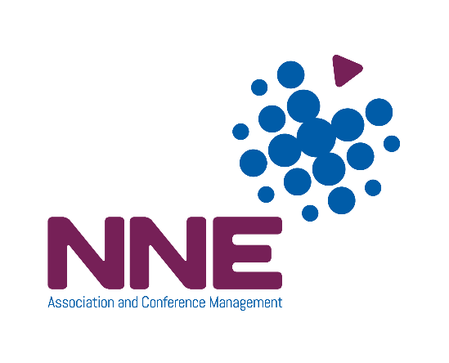

NAPICU Administration Office

Scottish Enterprise Technology Park, Nasmyth Building, 2nd Floor,
60 Nasmyth Avenue, East Kilbride, Glasgow, G75 0Q
Phone: +44 (0)1355 244 585 Email: info@napicu.org.uk

