NEWS2 RT Protocol- Physical Health Observations
Frequency: EVERY 15 MINUTES, FOR AT LEAST ONE HOUR. Further monitoring beyond 1 hour should be considered if deemed clinically appropriate (scoring is above 3 for single parameter or total above 4).
If you are unable to carry out Physical Health observations, or the patient refuses you must complete Non-Contact Observations of respiratory rate and level of consciousness using AVPU and record these on this chart.
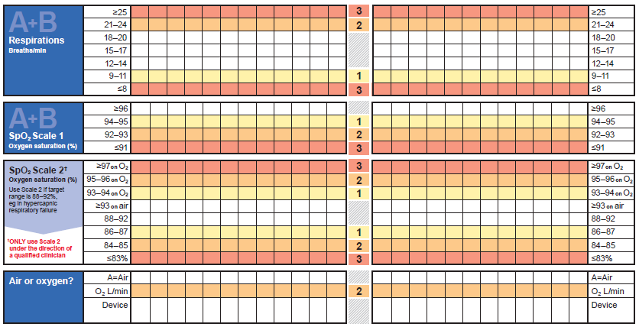
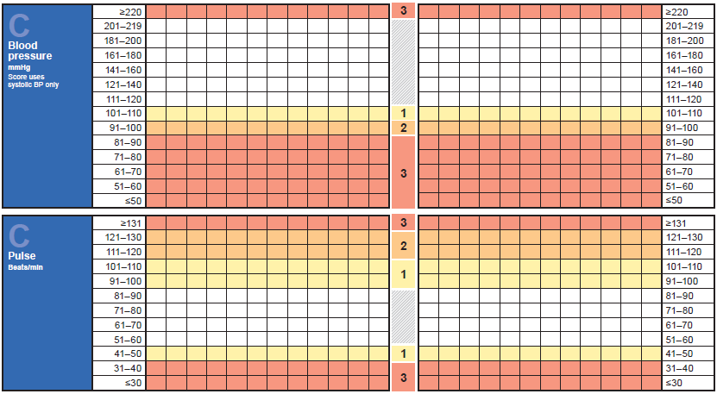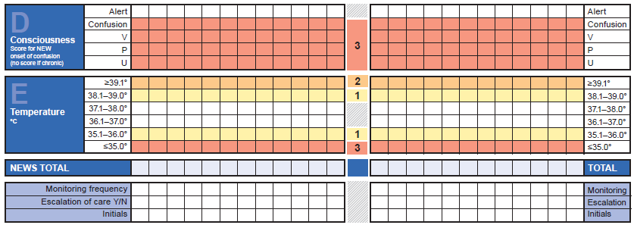
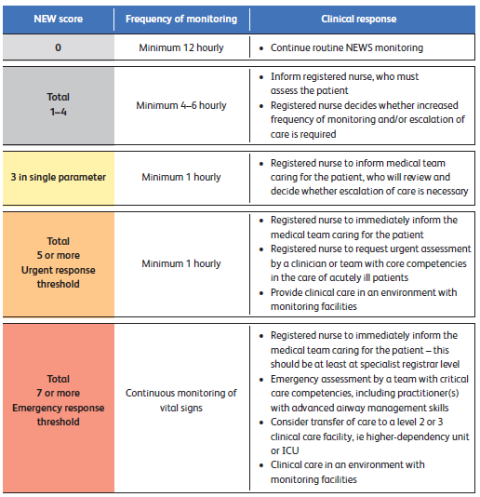
n their clinical judgement.
NEWS | Frequency of Monitoring | Clinical Response | Variants - Patient Specific
0 | Routine monitoring of physical observations | - Continue routine NEWS monitoring with every set of physical health observations | Please specify frequency of monitoring physical observations:
Total score 1 - 4 (if 3 in one parameter, see below) | Twice daily physical observations & discuss with Medical Team | - Inform Registered Nurse who must assess the patient;  - Registered Nurse to decide if increased frequency of monitoring and / or escalation of clinical care is required;  - Discuss with Medical Team / Out Of Hours (guidance required)
SICK!  Total NEWS 5-6 or 3 in one parameter Consider sepsis red flag signs | Increase frequency of physical observations to a minimum of 1 hourly & discuss urgently with the Medical Team. .............................................................  SEPSIS RED FLAG SIGNS  Slurred speech  Extreme shivering/muscle pain  Passing no urine (in a day)  Severe breathlessness  I feel like I might die  Skin mottled/discoloured | - Registered Nurse to urgently inform the Medical Team caring for the patient.  - Urgent assessment by Medical Team (give handover using the *SBARD tool)  - Assess if transfer of the patient is required  - Consider 999 call for ambulance assistance if doctor is unable to assess within 20 minutes / or if concerns remain over the patient’s Physical Wellbeing.  - • CONSIDER SEPSIS SCREENING TOOL
ACT NOW!  Total NEWS 7 or more | Continuous monitoring of patient’s Physical Observations & Initiate an emergency call | - Registered Nurse to immediately inform the Medical Team caring for the patient – again out of hours;  - 999 call for emergency ambulance assistance to transfer patient to the nearest District General Hospital  - Contact patient’s Consultant / nominated Deputy  - CONSIDER SEPSIS SCREENING TOOL

Escalation Protocol SBARD
S  Situation | Your name / designation / ward The patient’s name is .. I am concerned because … The NEWS score trigger is.
B  Background | Treatment Date  Brief history Admission Date MHA Status Medication / therapy
A  Assessment | A  Airway | Is the patient talking? Any airway noises; e.g. gurgling/stridor
 | B  Breathing | Respiratory Rate (RR)? Any respiratory noises e.g. wheeze? Is breathing laboured? Oxygen saturation levels (SpO2)?
 | C  Circulation | Heart Rate (HR)? Capillary Refill Time (CRT)? Blood Pressure (BP)?  Temperature?
 | D  Disability | Level of consciousness (AVPU)? Blood sugar levels? Pupil reactions?
 | E  Exposure | Exposure & environment Bleeding / rashes, etc.? Any other abnormal signs?
R  Recommend | I would like you to do /What would you like me to do?
D  Decision  *Use SBARD Tool (above) to notify Medical Team | Record what has been agreed on the patient’s notes.

